**ZC-N32D NUC Motherboard 12x12cm Size Integrated Alder Lake-N Series Processor ,2*Network Card,2*RS232,VGA+HDMI Display**

**DC12V Power Supply,Fanless Design**

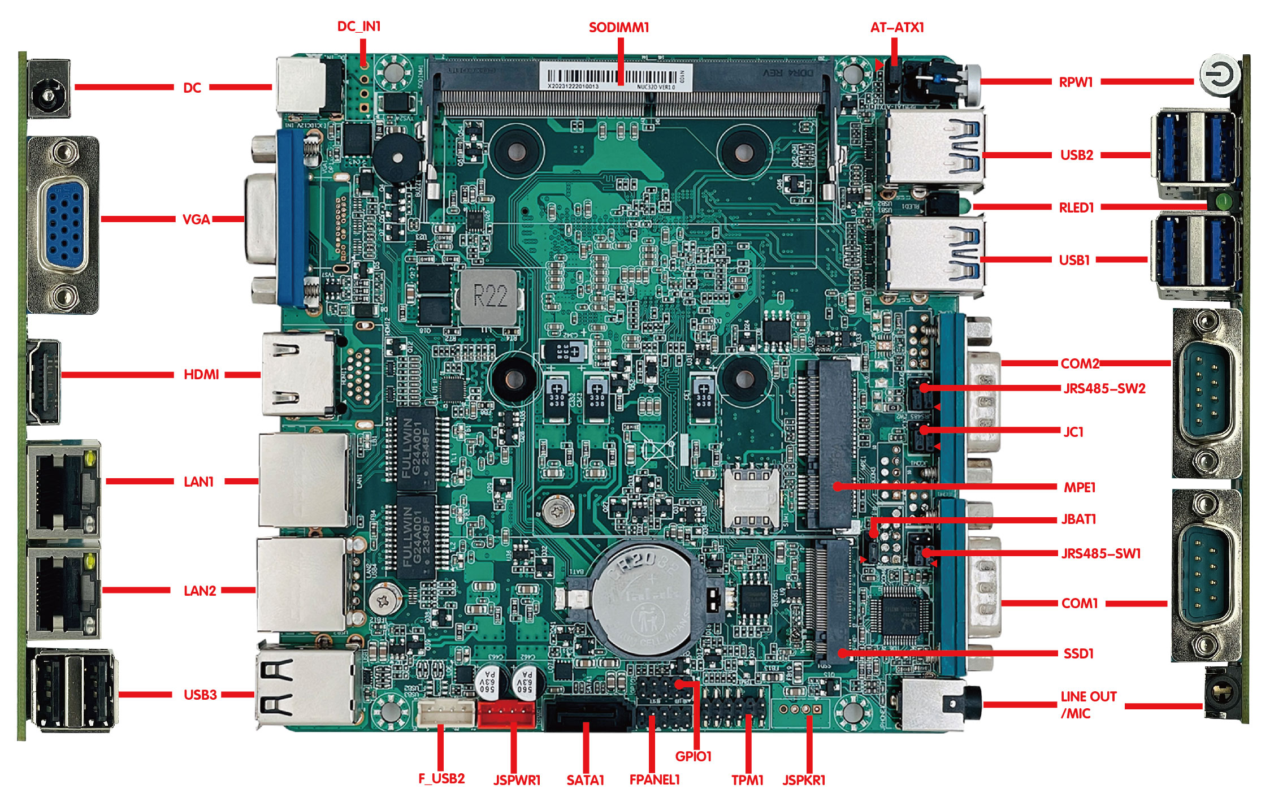

**Main Features:**

1.) Integrated Alder Lake-N Series Processor

2.) With 1* SO-DIMM 4 Slot, Up to 16GB

3.) 2* Realtek Gigabit Network Card

4.) Storage 1* SATA+1*M.2 Key-M

5.) With 2*RS232,RS485 Optional

6.) Fanless Design,Zero noise

**ZC-N32D NUC Nano Itx Motherboard**

|  |  |
| --- | --- |
| **Model** | **ZC-N32D** |
| **CPU** | Alder Lake-N Series Processor |
| N100 CPU,4 Cores 3.4GHz,6MB Smart Cache,TDP 6W |
| N200 CPU,4 Cores 3.7GHz,6MB Smart Cache,TDP 6W |
| N95 CPU,4 Cores 3.4GHz,6MB Smart Cache,TDP 6W |
| I3-N305 CPU,8 Cores 3.8GHz,6MB Smart Cache,TDP 15W |
| **RAM** | 1* SODIMM DDR4 3200MHz DDR4,up to 16GB |
| **Display** | Intel UHD Graphics |
| 1*DP,1* VGA(Default) |
|  | Can customize 2*HDMI; 1*HDMI+1*DP |
| **Network** | 2* Realtek Gigabit Network,Support PXW,Wake on LAN |
| **Storage** | 1* 7pin SATA3.0 6Gbps |
| 1* M.2 Key-M 2280/2242 PCIE/SATA SSD |
| **Expansion** | 1* Mini-PCIe for 4G/WIFI |
| **Rear I/O** | 2* LAN RJ45 |
| 2* USB2.0 |
| 1* HDMI+1*VGA |
| 1* 12V DC |
| **Front I/O** | 4* USB 3.1 |
| 1* HDD Light |
| 1* Power Button |
| 1*Line Out,1*Mic In |
| 2* COM (RS232 Default,COM1/2 can change to be RS485 by jumper) |
| **Inside I/O** | 1*TPM2.0 (2*6Pins) |
| 1* USB 2.0 (1*4Pins) |
| 1* SATA Power Pin |
| 1* 4pin DC Power |
| 1* Front panel switch button and indicator light 2*5Pin |
| 1*Amplifier 1*4Pins 2W5Ω(Customize) |
| **FAN** | Fanless cooling design, reserved 1*4pin CPU fan interface |
| **GPIO** | Support 4 input and output GPIO 2*5Pins |
| **BIOS** | 128Mb Flash ROM |
| **Watchdog** | Support hardware reset function (256 levels, 0~255 seconds) |
| **OS** | Windows 10/11/Linux |
| **Power Supply** | DC 12V |
| **Working Temp** | -10℃ to 60℃ |
| **Storage Temp** | -20℃～70℃ |
| **Working Humidity** | 5%-95% relative humidity, no condensation |
| **Size** | 120mm x 120mm |

**Ordering Info:**

|  |  |  |  |  |  |  |  |  |  |  |  |  |
| --- | --- | --- | --- | --- | --- | --- | --- | --- | --- | --- | --- | --- |
|  | **Model** | **CPU** | **Core** | **Frequency** | **TDP** | **RAM** | **HDMI** | **DP** | **LAN** | **USB** | **COM/485** | **POWER** |
| 1 | ZC-N32D-N95 | N95 | 4 | Up to3.4G | 15W | DDR4 | 1 | 1 | 2 | 7 | 2 / 2 | 12V |
| 2 | ZC-N32D-N100 | N100 | 4 | Up to3.4G | 6W | DDR4 | 1 | 1 | 2 | 7 | 2 / 2 | 12V |
| 3 | ZC-N32D-N200 | N200 | 4 | Up to3.7G | 6W | DDR4 | 1 | 1 | 2 | 7 | 2 / 2 | 12V |
| 4 | ZC-N32D-N305 | I3-N305 | 8 | Up to3.8G | 15W | DDR4 | 1 | 1 | 2 | 7 | 2 / 2 | 12V |